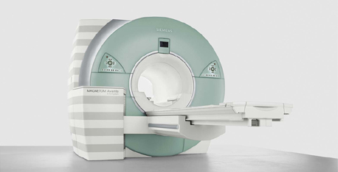
Diagnostic Center "MEDEX" is located on the area of 300 square meters. It has a unique MR tomography, produced by SIEMENS, Germany (1.5 Tesla, 18 channels). There are no analogues in Ukraine with the opportunities, presented by our center.

There are a routine and highly specialized study of brain and spinal cord, cardiovascular system, abdomen, joints, breast and others.
MAGNETOM Avanto provides a new level of pristine image quality with unprecedented acquisition speed and ease of use. The unique combination of leading magnet and gradient technology together with revolutionary image acquisition techniques provides unsurpassed clinical benefits:
• High diagnostic confidence due to exceptional magnet homogeneity for excellent fat saturation.
• Large 50 cm Field of View (FoV).
• Strong gradients for high resolution and short scan times.
• Unparalleled flexibility, accuracy, and speed thanks to Tim (Total imaging matrix) technology.
The tomography in our center has the unique technology – Tim (Total imaging matrix).
Tim® is providing unprecedented flexibility, accuracy, and speed. By combining coils in any way, Tim technology helps for example to reduce examination times by up to 50%. Around the world, Tim has become a standard in MRI. With thousands of installations, this is proven every day.
Tim benefits: Tim is a Siemens-unique technology which seamlessly integrates a high number of coil elements with a high number of RF channels.
Our tomography has the most powerful in the industry gradients SQ engine (amplitude 45mTl / m, the speed increase of 200 T / m / s).
Among the advantages of our system should be noted:
- The possibility of obtaining high-quality image sequence (EPI in the early stages of stroke).
- Examination of the heart and blood vessels without contrast.
- A full cycle of research findings and design specialist takes 30 minutes.
- Verification of good quality tumor.
- The ability to keep high-resolution tomogram and contrast of the body without changing the position or coils.
One of the areas of center’ specialization is participation in clinical trials. We act as an independent contractor for magnetic resonance imaging. Since 2009, LLC "DC" MEDEX" has successfully implemented various projects. Our MR specialists have an experience in the fields of neurology and rheumatology.Our center is a special unit which deals with the organization and information technology background of clinical trials, introduced internal quality control system. All clinical trials are implemented in accordance with international standards and legal framework of Ukraine.
Friendly staff and spacious rooms make the desirable comfort for patients. Our staff consists of experienced doctors (over 10 years of experience), with the highest categories and degrees.
Flexible work schedule makes it possible to conduct an examination at a convenient time for the patient:
Mon. - Sun. 8:00 am - 10:00 pm
High-performance system allows high-quality examination at competitive prices. MRI Center is located in a convenient, easily accessible place with its own parking.
(03186, Kyiv, Aviaconstructor Antonov, 13 Str.)
You can contact us:
Tetyana Konotopska
+38 044 520 18 89, +38 067 401 67 70;
e-mail: dcmedex.mri@gmail.com
Out team of MR specialists is always ready to meet all your requirements and find the best technical solution for clinical trial!

